A report OR a demo on how to set up a project moderator/lead position from the instructor-side

Creating your project repository

Access github webpage at

https://github.com/

on the upper right corner of the home screen click Sign In



In the following page enter your login and password.

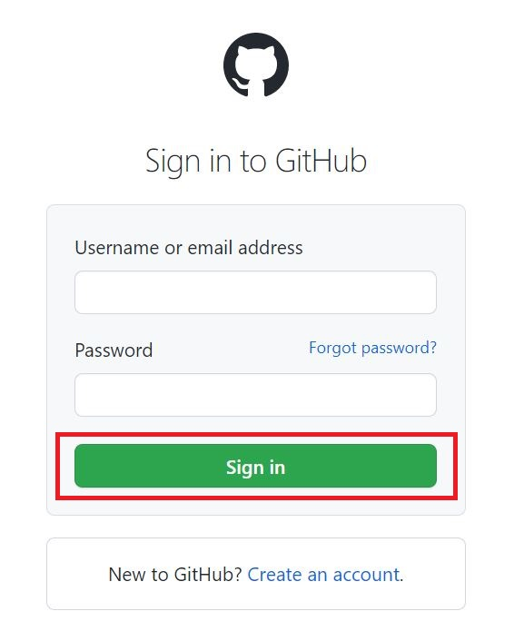
Click Sign in

In the following page click Create repository

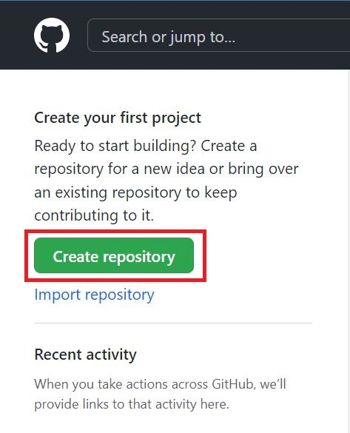
Select Owner (current login) and enter name for your repository.
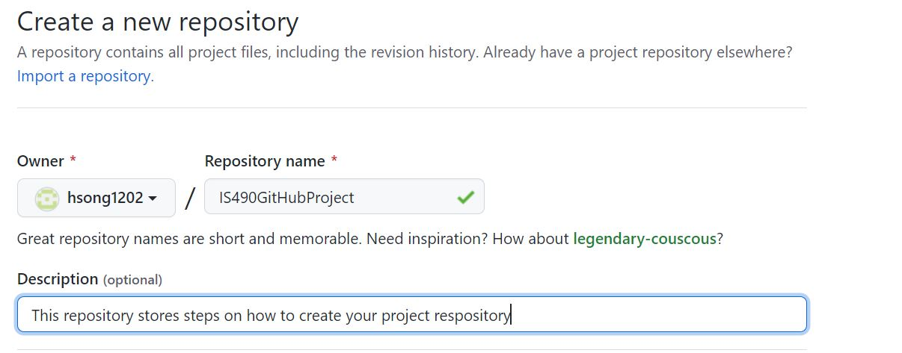
Below the Description field there are options to make the repository public or private, I recommend setting it private.
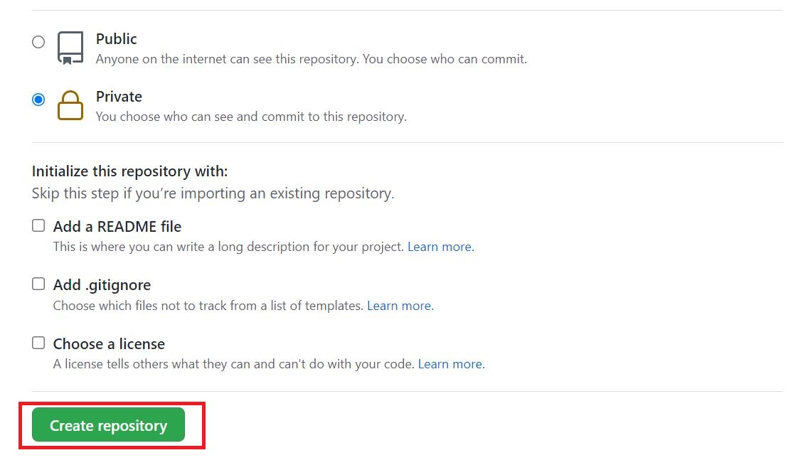
You also have an option to add a README file but it is not optional.
Click Create repository to finish creating the repository

Uploading your project to newly created repository
In the following screen, click uploading an existing file in the Quick setup window.
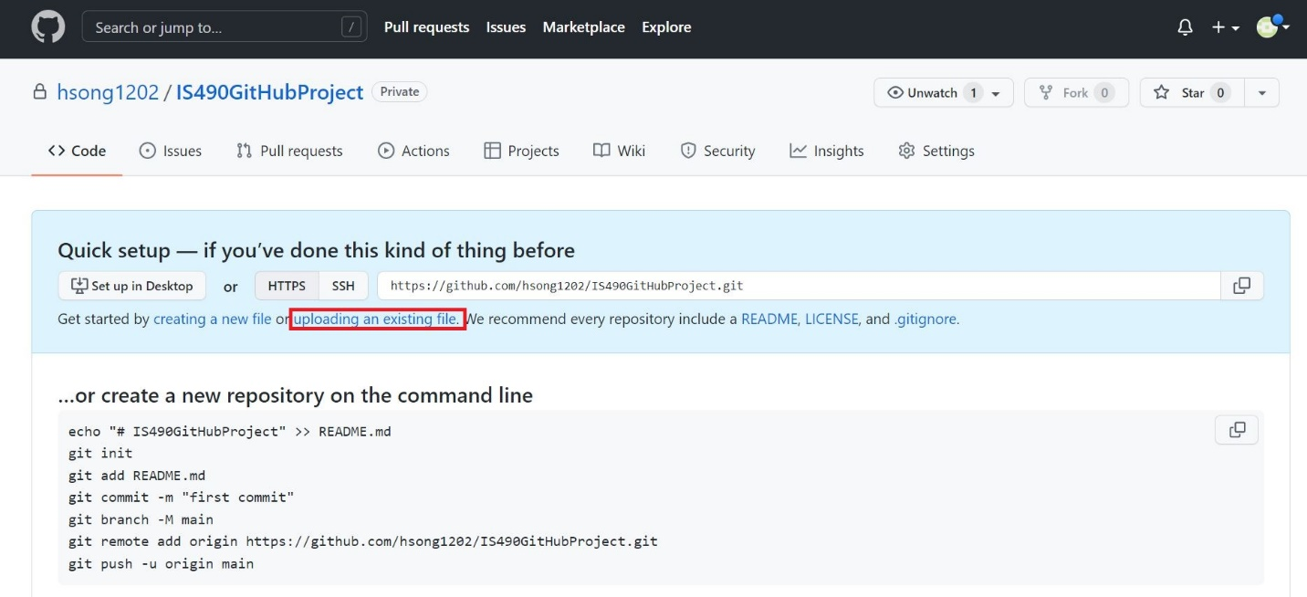
Upload files by dragging and dropping them or adding them from the browser
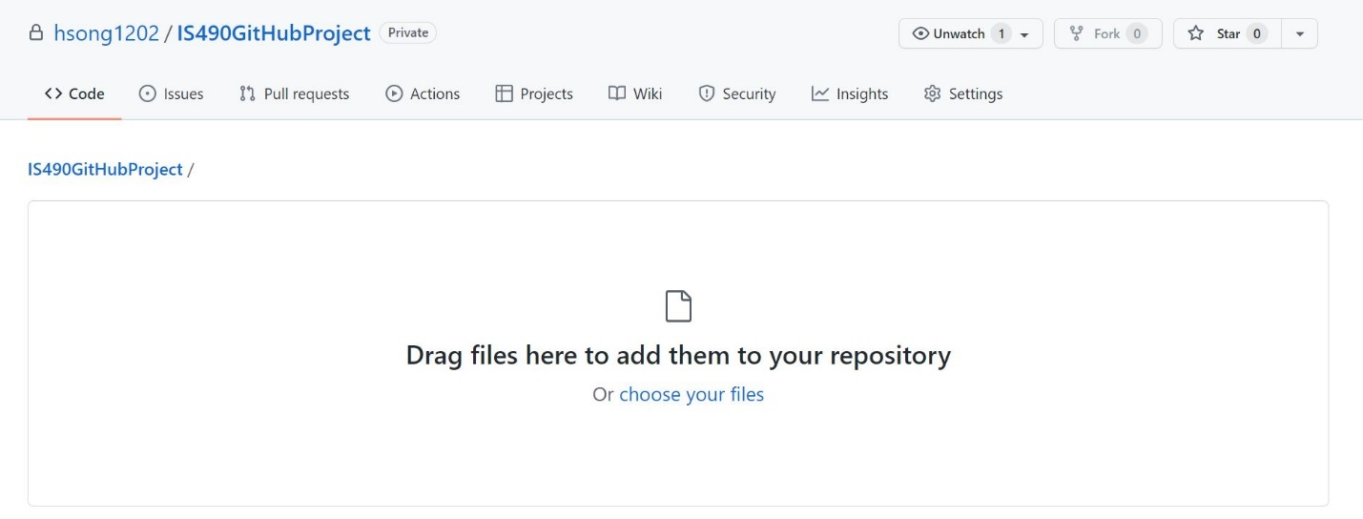
Once you have selected the items to upload, write a summary of the upload and press Commit changes.
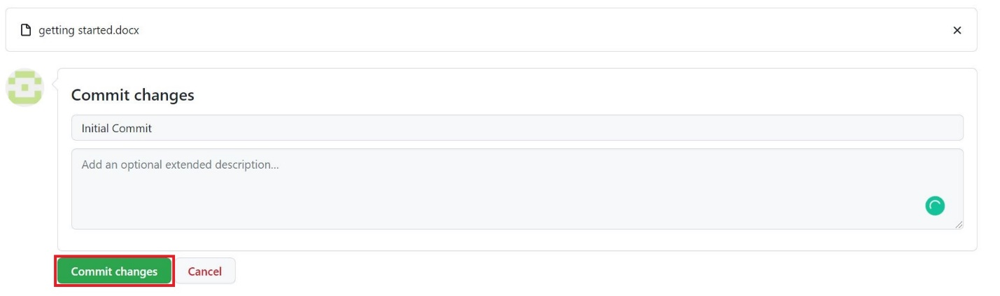

linking your repository with your GitHub Desktop
open GitHub Desktop App
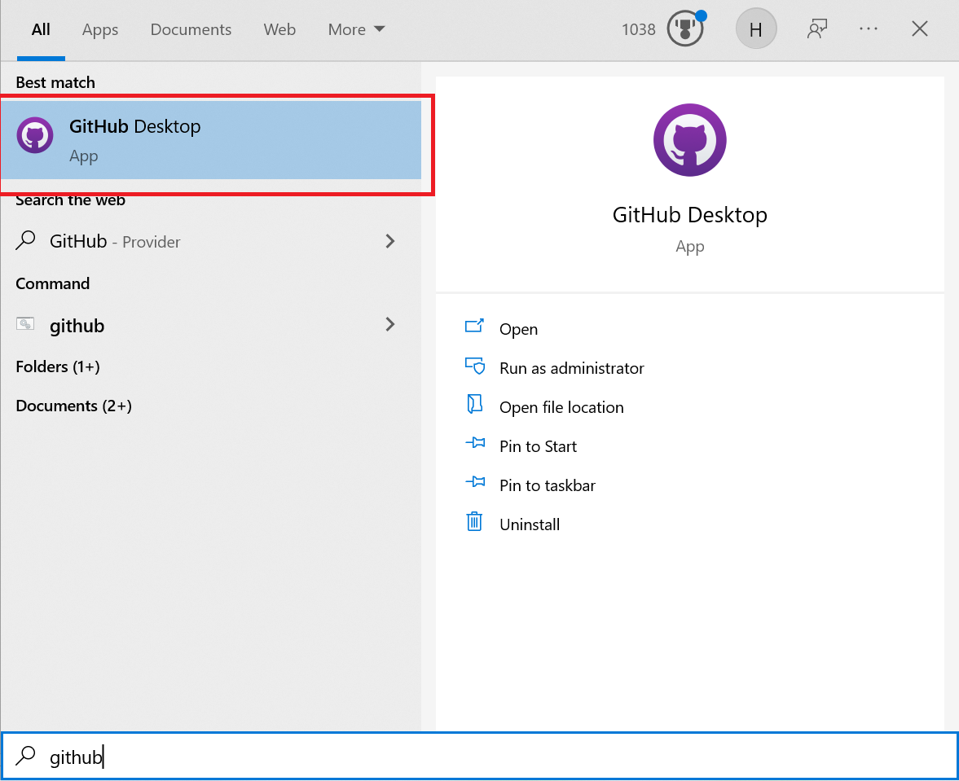
In the
